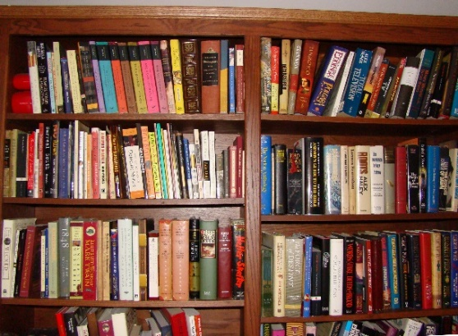

Friends of the Library March Book Sale

***All books are “Half Price” during the month of March. Outfit your home, classroom, or business libraries with a wide selection of Adult Fiction, Non-Fiction, Young Adult, Children’s and other books to select from in our bookstore.***

**Note: Most paperback books are regularly priced at $.50 and hard cover books regularly priced at $1.00 throughout the bookstore *SO WHAT A DEAL* it will be shopping in the Bookstore during March!!!!!!**

**Hours:**

Monday: 2:00-5:00 p.m.

Tuesday and Wednesday: 2:00-8:30 p.m.

Thursday: 2:00-5:00 p.m.

Friday: 10:00-4:30 p.m.

Saturday: 10:00-1:00 p.m.